RF Conditioning 2018

### Application User Manual 0.1

### Duncan Scott, 23/02/2018

## Remember:

**CLARA: A Rolls-Royce Machine…**

**The operating standard is procedures, measurements and data acquisition should be automated and quantified.**

**CLARA requires quality, coherent calibrated data distributed to all**

**Don’t move the graph window.**

**Everything is fine ☺**

# Introduction

Automated RF conditioning on CLARA first started in March 2017. The long term aim is to completely automate RF conditioning, for all RF structures whilst also recording relevant data to log files.

This application is the latest (and not final) iteration of automatic RF conditioning script.

# RF Conditioning

The experimental goal is to increase the RF power following an RF Ramp File. The ramp file defines the number of RF pulses required to increase the RF power by the next amount. Whilst ramping various parameters are monitored and logged. The vacuum, Dark Current (DC) and LLRF Power/Phase traces are monitored and used to control the ramp rate.

The application is designed to run with the minimum of human intervention. This User Guide is to demonstrate how to start the application, with pictures, some basic exposition and known issues to look out for.

# First Start-up

1. Make sure the RF is ready to output power:

* The RF Protection should be enabled
* The Modulator should be Triggered
* The LLRF RF Output should be checked,
* The LLRF Amp-set and Phase locked should both be checked
* Set a low Amplitude Set-Point of 500
* If all the RF is working you should see power in the power traces,
  + e.g. Channel 1, P_REM for the Klystron Forward Power

1. Start The Conditioning Application by clicking the Desktop Icon on MCRDELL10:

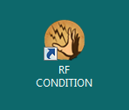

This will spawn a command prompt that runs through the script. The progress of the script will be displayed to this screen, and written to a log file. After some-time (approx.. 30 seconds) the main GUI will display.

Known Issues 1: RF Not On During Start-Up.

In this case the GUI will freeze (i.e. ‘*Not Responding*’ written in the Window Title Bar). The command prompt Text will display: **‘WARNING Expecting RF Power by now, mean power is …’**

The GUI and command prompt will look something like the below figure. Get the RF power on properly and restart the application

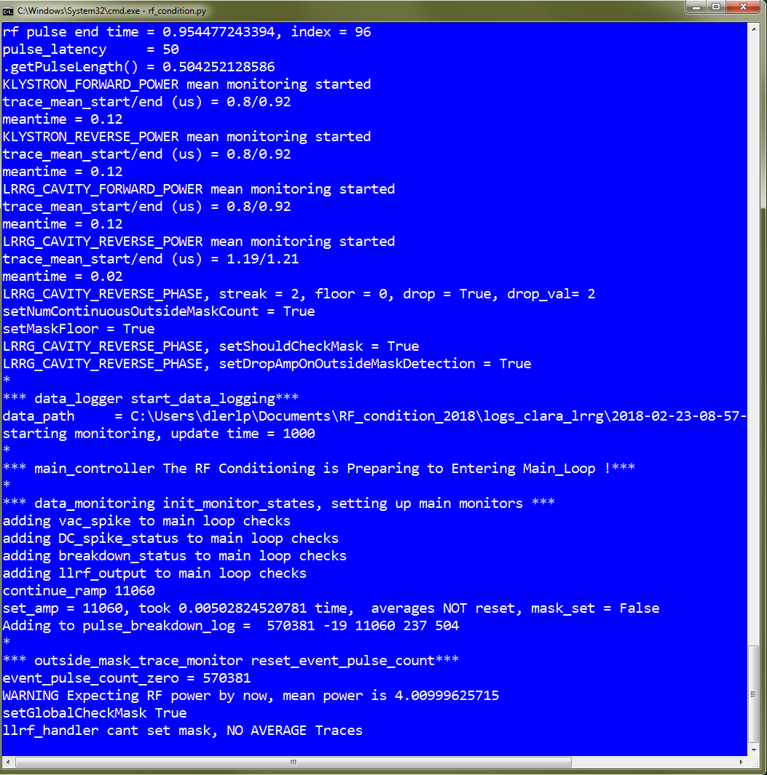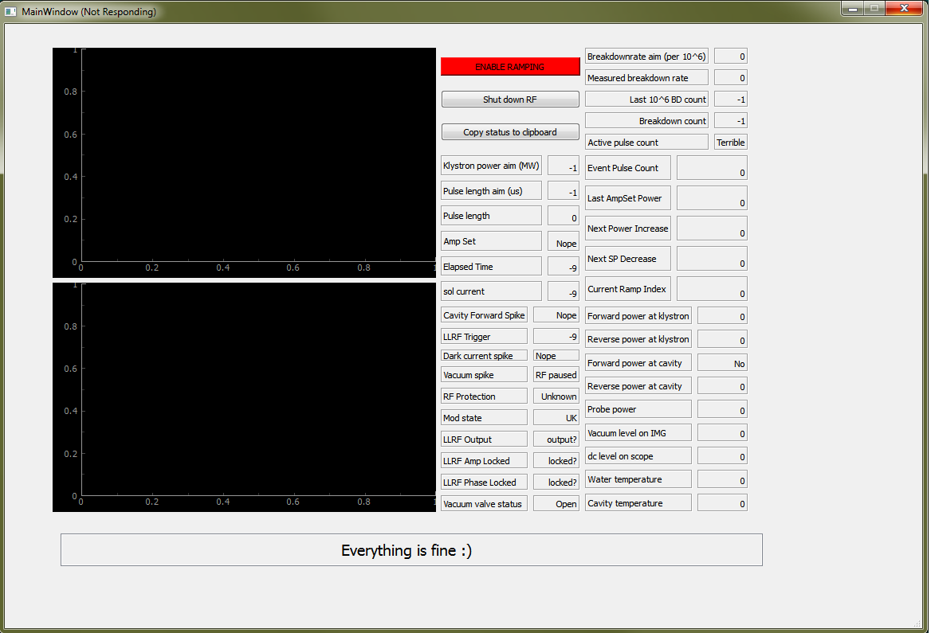

1. Successful Application Start-Up

On successful start-up the GUI should look something like (your vacuum valve status may be green or red, depending on if it is open or not):

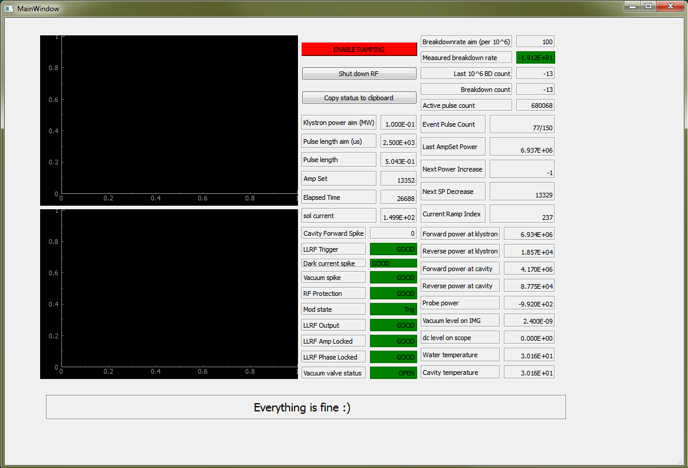

Settings are applied based on the log written during the previous runs of the application. Click the red ‘ENABLE RAMPING’ button to allow the application to increase the RF amplitude. At any time this button can be clicked to disable / enable increasing the RF power.

After enabling ramping the button should go green and the application can increase the RF amplitude. Hopefully, that is all, Everything is fine ☺, and the application will run.

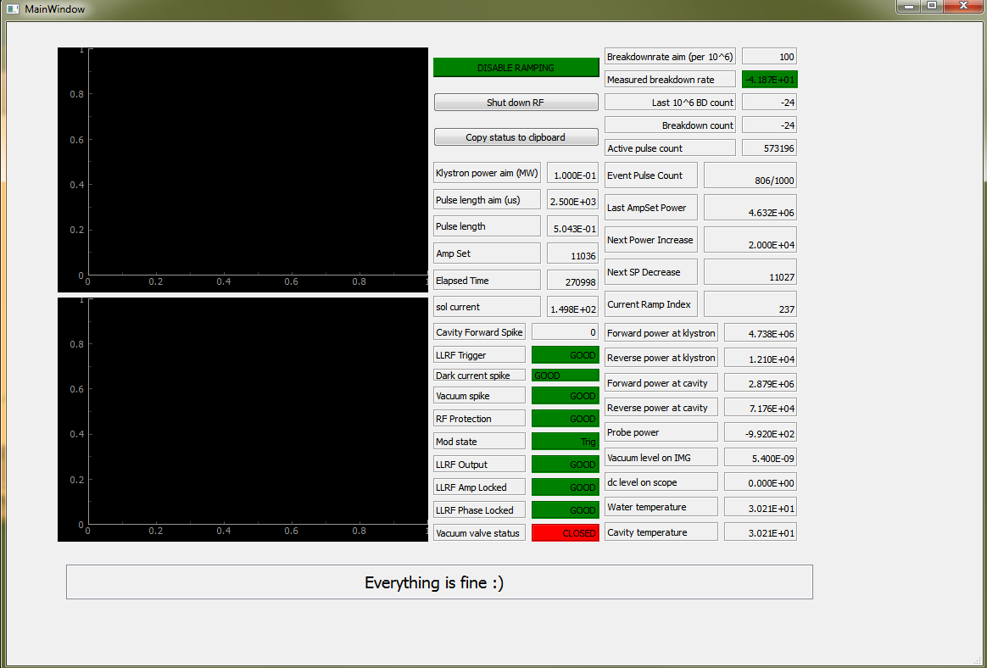

1. The Klystron Forward Power vs Amp Set Graph

The RF power ramp is defined in steps of Klystron Forward Power. In order to estimate the required amplitude set point data is taken and fitted. This process needs some initial data to fit, so the first few ramp-steps are done in set-point. After this initial data is taken a graph window will be displayed, and will look something like (the scales and points may differ depending where you are in the ramp).

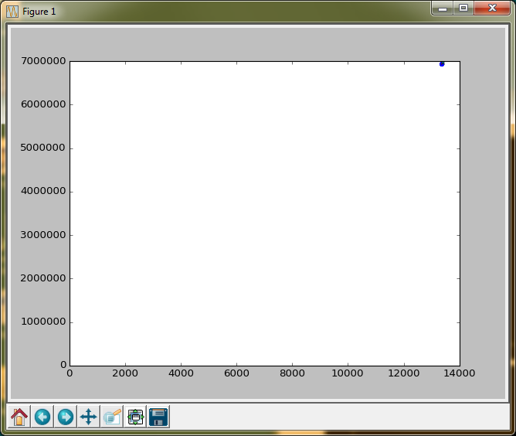

Klystron

Forward

Power

(Watts)

LLRF Amp Set-Point

*(crocodiles?)*

KNOWN ISSUES 2: The Graph Window Crashes The Application.

**For some reason that has not been investigated, moving the graph window crashes the application. Don’t move the graph window.**

**This feature will be dealt with in due course, for now: Don’t move the graph window.**

After fitting (and then many steps) the graphs will look something like below.

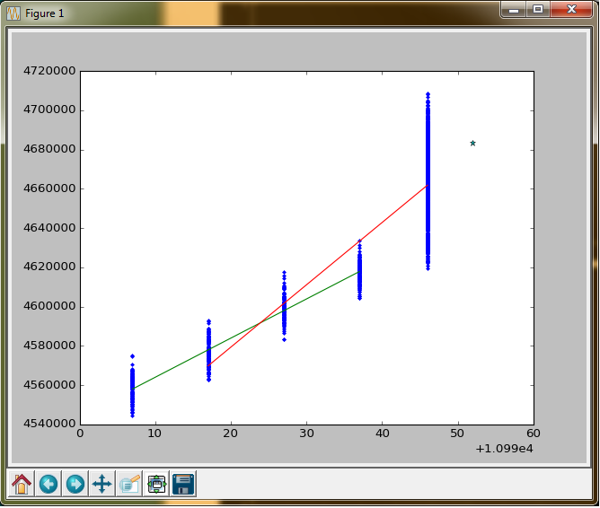

Blue – Data Points

Green – Previous Fit

Red - Current Fit

* - new set point / power

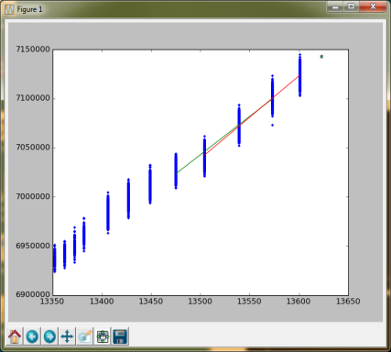

KNOWN ISSUES 3: After fitting the application decides to decrease set-point to increase power.

Rarely, but on occasion this can happen if there is a dip in RF power. This feature will be dealt with in due course, for now, restart the application.

# Events

The events that the application is looking for are vacuum spikes, DC spikes and RF breakdowns as seen in the LLRF traces. All these events are classed as ‘breakdowns’ and when they occur the breakdown count will increment. The breakdown-rate is defined as the number of breakdowns per million pulses. If the breakdown rate is too high the application will not increase the RF power, and may even start ramping the RF power down.

KNOWN ISSUES 4: False Positive Events

Unfortunately, the most common event so far seen is a false positive that is being attributed to the Libera-LLRF system not sending out synchronised data. This should not cause too many issues unless the breakdown rate gets too high. In that case the ‘*Measured breakdown rate*’ will go from green to red:



If the breakdown rate has gone red try calling Louise or Duncan.

After an event has occurred the *Event Pulse Count* is reset to 0.



The *Event Pulse Count* is the number of pulses required before the next ramp increase. If there are too many events then this pulse counter will always be reset to zero preventing the RF power to be increased. If you are seeing many “events” in the space of a few minutes with little to zero vacuum activity call Louise and Duncan.

# Changing the Pulse Length

At the moment this is not automated, If you get to the maximum RF Power Disable Ramping, soak for an hour and then call Duncan and Louise.

# Things to watch while Conditioning

Striptool stuff …

# Remember

**Everything is fine ☺**